Oasis Dementia Dataset

About the Oasis Dataset
Sample Size = 373 rows, Feature Count = 15 columns, Clinical Focus = Temporal changes.

What is a Longitudinal Study?
In data science and medical research, a Longitudinal Study is one where you observe the same subjects repeatedly over a period of time. It allows us to calculate the rate of change.
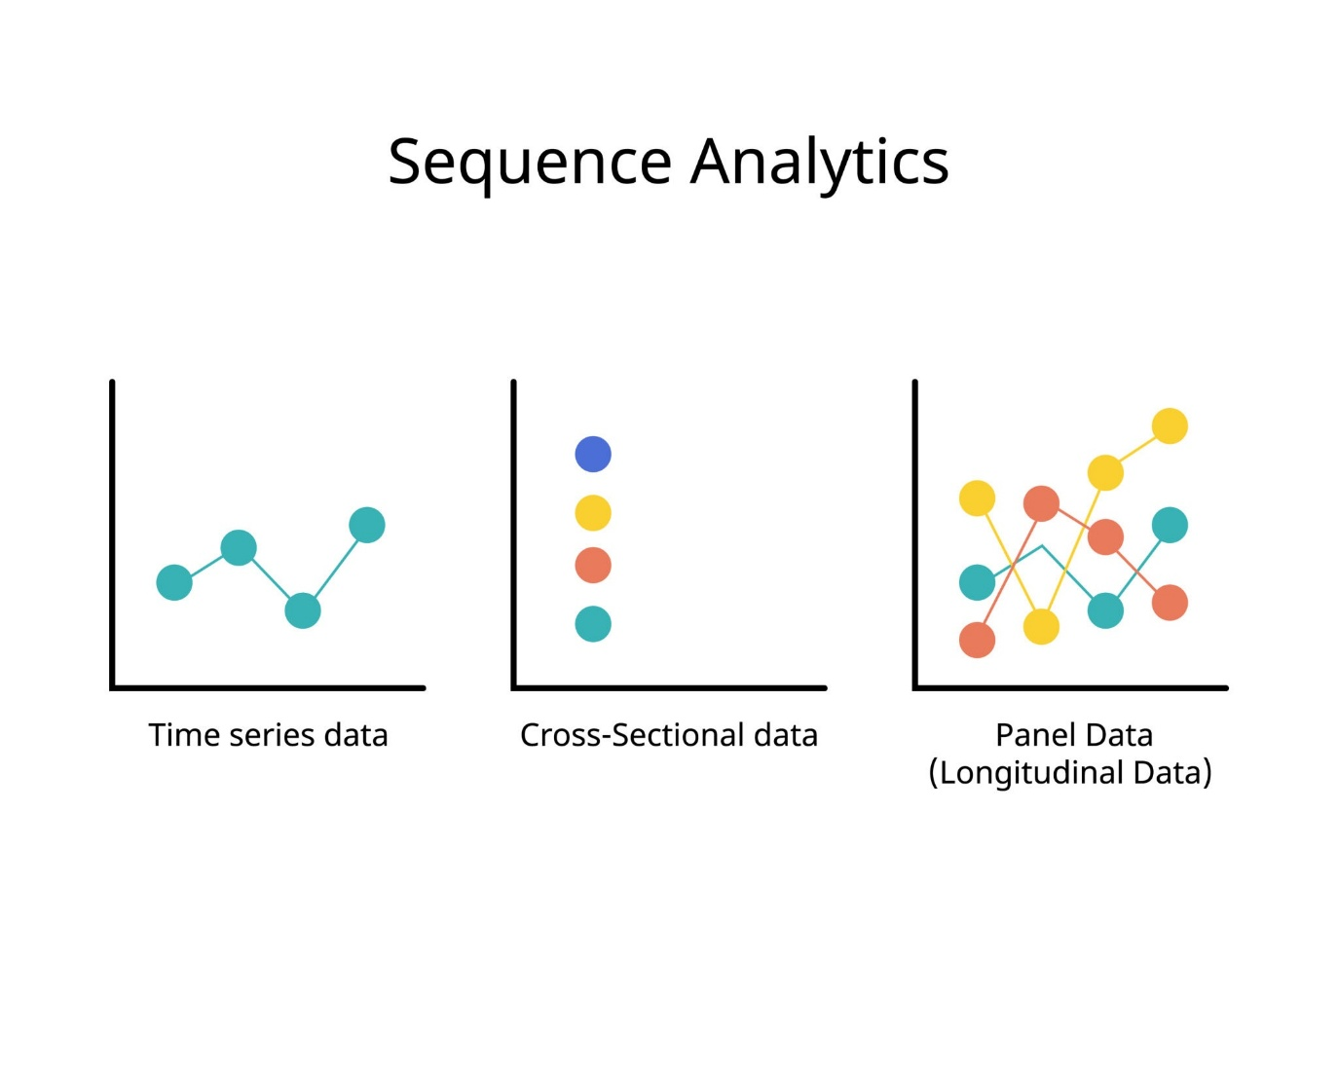The Dataset consists of three groups/columns, Nondemented, Demented and Converted.
- Nondemented: Stayed healthy throughout the study.
- Demented: Had dementia from the start.
- Converted: These patients started as Nondemented but became Demented during the study.

Feature Engineering Task: Should we use only the first visit to predict the final diagnosis? Or should we calculate the difference in brain volume (nWBV) between visits as a new feature?

